**Daily Assessment**

**Muhammad Ammar Chaudhry**

**SU92-BSCSM-F23-269**

**BSCS-1G**

**----------------------------------------------------------------------------------------------------**

**Q#41:**

#include <iostream>

using namespace std;

int main()

{

if (4 * 7 == 74 / 3) {

cout << "a. True" << endl;

} else {

cout << "a. False" << endl;

}

if (4 + 7 / 2 <= 9 - 15 % 6) {

cout << "b. True" << endl;

} else {

cout << "b. False" << endl;

}

if ('K' < 'k') {

cout << "c. True" << endl;

} else {

cout << "c. False" << endl;

}

if ('+' <= '-') {

cout << "d. True" << endl;

} else {

cout << "d. False" << endl;

}

if ('5' <= '6') {

cout << "e. True" << endl;

} else {

cout << "e. False" << endl;

}

if (3.9 / 4 - 6 >= 8 - 6.2 * 1.5) {

cout << "f. True" << endl;

} else {

cout << "f. False" << endl;

}

return 0;

}

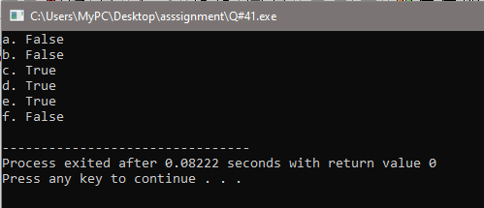

**Q#42:**

#include<iostream>

using namespace std;

int main()

{

if ('+' < '-')

cout << "+-";

cout << "-+" << endl;

if (12 / 2 == 4 + 1)

cout << "6 ";

cout << "12 / 2 != 4 + 1" << endl;

if ('*' >= '/')

cout << "/";

cout << "*";

cout << endl;

if ("C++" <= "++C")

cout << "C++" << endl;

cout << "C++" << endl;

if ("low" <= "high")

cout << "low" << endl;

cout << "high" << endl;

}

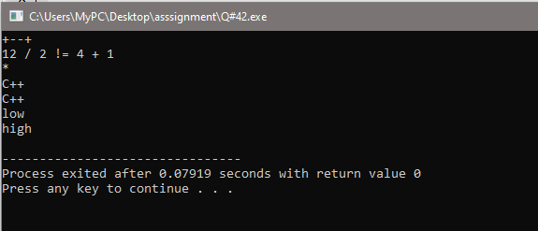

**Q#43:**

#include<iostream>

using namespace std;

int main()

{

int num;

cout<<"Enter a number ";

cin>>num;

if(num%2==0)

{

cout<<"You enter an Even number";

}

else

{

cout<<"You enter an Odd number";

}

}

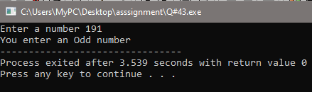

**Q#44:**

#include <iostream>

using namespace std;

int main() {

int number;

cout << "Enter an integer: ";

cin >> number;

if (number > 0) {

cout << "Positive" << endl;

} else if (number < 0) {

cout << "Negative" << endl;

} else {

cout << "Zero" << endl;

}

return 0;

}

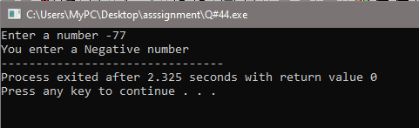

**Q#45:**

#include <iostream>

using namespace std;

int main() {

int number;

cout << "Enter a number: ";

cin >> number;

if (number >= 10 && number <= 20) {

cout << "10 to 20" << endl;

} else if (number >= 30 && number <= 40) {

cout << "30 to 40" << endl;

} else {

cout << "Other range" << endl;

}

return 0;

}

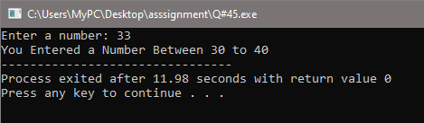

**Q#46:**

#include <iostream>

using namespace std;

int main() {

int age;

cout << "Enter your age: ";

cin >> age;

if (age >= 18) {

cout << "Eligible to vote" << endl;

} else {

cout << "Ineligible to vote" << endl;

}

return 0;

}

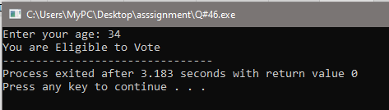

**Q#47:**

#include <iostream>

using namespace std;

int main() {

int number;

cout << "Enter a number: ";

cin >> number;

if (number % 2 == 0 && number % 3 == 0) {

cout << "Divisible by both 2 and 3" << endl;

} else {

cout << "Indivisible by both 2 and 3" << endl;

}

return 0;

}

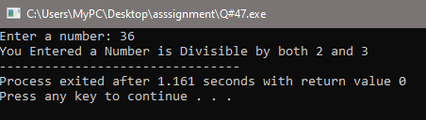

**Q#48:**

#include <iostream>

using namespace std;

int main() {

int num1, num2;

cout << "Enter the first number: ";

cin >> num1;

cout << "Enter the second number: ";

cin >> num2;

if (num1 == num2) {

cout << "Equal" << endl;

} else if (num1 > num2) {

cout << "Greater" << endl;

} else {

cout << "Smaller" << endl;

}

return 0;

}

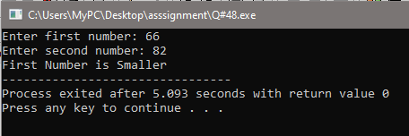

**Q#49:**

#include <iostream>

using namespace std;

int main() {

int year;

cout << "Enter a year: ";

cin >> year;

if ((year % 4 == 0 && year % 100 != 0) || (year % 400 == 0)) {

cout << "Leap year" << endl;

} else {

cout << "Not leap year" << endl;

}

return 0;

}

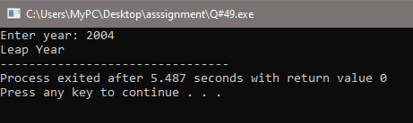

**Q#50:**

#include <iostream>

using namespace std;

int main() {

int angle1, angle2, angle3;

cout << "Enter the first angle: ";

cin >> angle1;

cout << "Enter the second angle: ";

cin >> angle2;

cout << "Enter the third angle: ";

cin >> angle3;

int sum = angle1 + angle2 + angle3;

if (sum == 180) {

if (angle1 < 90 && angle2 < 90 && angle3 < 90) {

cout << "Acute triangle" << endl;

} else if (angle1 > 90 || angle2 > 90 || angle3 > 90) {

cout << "Obtuse triangle" << endl;

} else if (angle1 == 90 || angle2 == 90 || angle3 == 90) {

cout << "Right triangle" << endl;

}

} else {

cout << "Invalid triangle (Sum of angles not equal to 180)" << endl;

}

return 0;

}

